**ExperimentNo.1.4**

**Student Name:** Gaurav Kumar **UID:** 22MCC20177

**Branch:** MCA**–**CCD **Section/Group:** MCD-1/A

**Semester:** III **Date of Performance:** 14th Oct 23

**Subject Name:** Business Analytics **Subject Code:** 22CAH-703

1. **Aim/Overview of the practical:**
   1. Analysis using charts and graphs, chart styles.
   2. Changing Chart layouts, add labels, axis options, chart title, legends, data labels.
   3. Sharing worksheets and Workbooks using freezing panes.
2. **Code for practical: (a)**
3. Open Excel and add data on which you want to apply operations.
4. Select the columns or range for which you want to create a chart.
5. Go to the **Insert tab** and select the type of chart you need from the **charts option**.

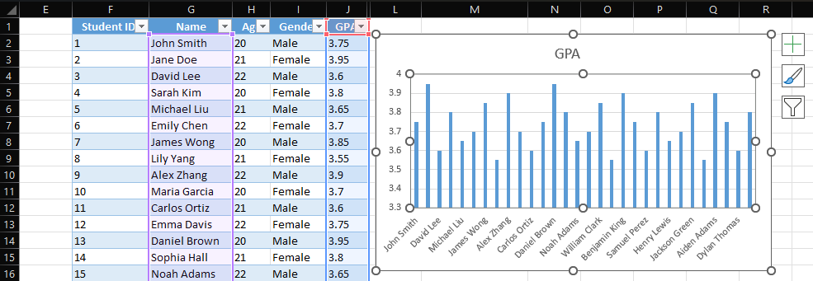

1. Now, a chart will appear on the sheet you can further customize it.

**Code for practical: (b)**

1. To modify click on chart a new **“+” label** will appear you can modify most of the things of chats using that**.**
2. A new menu will appear to add an axis option select **Axis Tiles** option and edit the appear x and y axis label.
3. From that menu you can also add **Legend**, **Data label** and many more options.

**Code for practical: (c)**

1. To share worksheets and Workbooks with freezing panes**.** First apply the freezing pane on the worksheet.
2. Go to **View tab** under **window group** click on **Freeze Panes.**
3. A drop-down menu will appear select the row, column, and row & column option to freeze the panes.

1. Now, the select pane will freeze even if you scroll the whole page but the desire pane will always be on the top or left as applied.
2. Now to **share the worksheet**, Go to **File tab** a newwindowwill appear click on share.
3. And another window will appear with share options. Select the desired share option. You can either **email** theworksheet or can share worksheet with **People** on drive.

